
RAMAIAH
Institute of Technology
USN | 1 | M | S

(Autonomous Institute, Affiliated to VTU)
(Approved by AICTE, New Delhi & Govt. of Karnataka) Accredited by NBA & NAAC with ‘A’ Grade

MAKEUP EXAMINATIONS – FEBRUARY 2019

Course & Branch | : | B.E : Computer Science and Engineering | Semester | : | V
Subject | : | Computer Networks | Max. Marks | : | 100
Subject Code | : | CS53/CS1553 | Duration | : | 3 Hrs

Instructions to the Candidates:
- Answer one full question from each unit.
- Write figures wherever necessary.

 |  | UNIT- I
1. | a) | Describe HTTP request and response message with examples. | CO1 | (12)
 | b) | Differentiate between Recursive and Iterative DNS queries with neat figures. | CO1 | (08)
2. | a) | Compare and contrast SMTP with HTTP. | CO1 | (04)
 | b) | Why is FTP called “Out of band protocol”? Explain. | CO1 | (04)
 | c) | Explain Distributed Hast Tables – linear, Circular DHT and circular DHT with shortcuts. | CO1 | (12)
 |  | UNIT– II
3. | a) | Illustrate with neat figure connection oriented multiplexing and demultiplexing. | CO2 | (08)
 | b) | Describe why an application developer might choose to run an application over UDP rather than TCP. | CO2 | (04)
 | c) | Draw the neat flow diagram for the following scenarios:  - Retransmission due to lost acknowledgement.  - Cumulative acknowledgment avoids retransmission of first segment.  - Retransmitting the missing segment before the timer expires. | CO2 | (08)
4. | a) | What is fast retransmit? Write the advantage of using it? | CO2 | (06)
 | b) | Draw an FSM that describes TCP congestion control. | CO2 | (08)
 | c) | Illustrate with neat figures the sequence of TCP states visited by the TCP client and TCP server. | CO2 | (06)
 |  | UNIT- III
5. | a) | Discuss the IPv6 packet format in detail. | CO3 | (06)
 | b) | Using Dijiksra's and Bellman-Ford algorithm, find the least-cost path from node A to node B illustrating each step in tabular format.  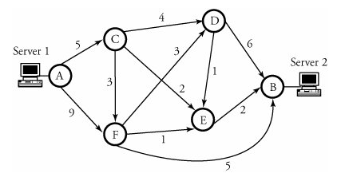 | CO3 | (08)
 | c) | What is the difference between a group-shared tree and a source-based tree in the context of multicast routing? Explain with an example. | CO3 | (06)
6. | a) | Suppose that a host application needs to transmit a packet of 4200 bytes. The physical layer has an MTU of 1,500 bytes. The packet has an IP header of 20 bytes plus another attached header of 20 bytes. Fragment the packet, and specify the ID, MF, and offset fields of all fragments. | CO3 | (06)
 | b) | What is address depletion? How DHCP and NAT help in address depletion? Compare the usage of DHCP and NAT to address this issue. | CO3 | (06)
 | c) | Discuss briefly RIP distance vector routing protocol with suitable formulas and updating of routing table in RIP using split-horizon and poisoned-reverse rule. | CO3 | (08)
 |  | UNIT- IV
7. | a) | Explain the principal components of the 802.11 wireless LAN architecture. Describe the role of the beacon frames in 802.11. | CO4 | (06)
 | b) | Illustrates the steps involved when a base station does decide to hand off a mobile user. | CO4 | (07)
 | c) | Differentiate between direct and indirect routing to a mobile node. | CO4 | (07)
8. | a) | Discuss five steps of Protocol-Independent Multicast (PIM) protocol for a domain with n LANs with suitable example. | CO4 | (07)
 | b) | Explain the cellular network architecture, 2G where Voice Connections to the Telephone Network. | CO4 | (07)
 | c) | Find the shortest path trees for router R for below topology if the network is using MOSPF with the source connected to the router marked as S. Assume that all routers have interest in the corresponding multicast group.  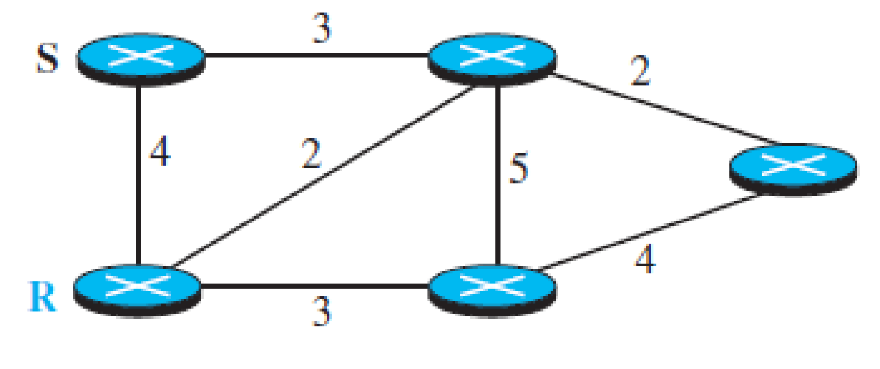 | CO4 | (06)
 |  | UNIT- V
9. | a) | Explain RTP packet header with neat figure. | CO5 | (08)
 | b) | Explain any two scheduling algorithms with examples. | CO5 | (08)
 | c) | Differentiate between leaky bucket and token bucket algorithm. | CO5 | (04)
10. | a) | Explain session initiation protocol. | CO5 | (10)
 | b) | Explain DiffServ operation with a neat figure. | CO5 | (06)
 | c) | Illustrate CDN interactions with DNS. | CO5 | (04)

****************

